5.1

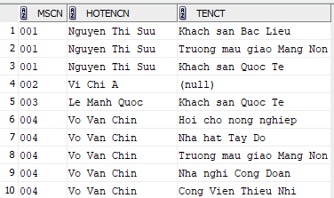  
……………………………………………………………..

……………………………………………………………..

5.2

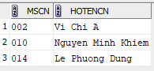

5.3

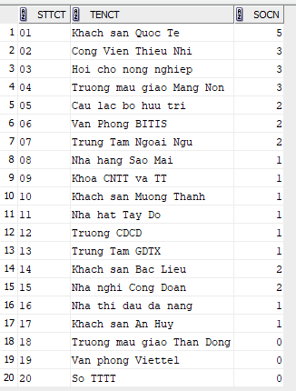

5.4

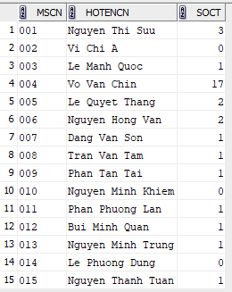

5.5



5.6

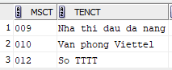

5.7

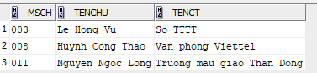

5.8



5.9

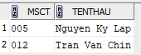

5.10

